Towards single-crystal 2D van der Waals materials synthesis in a wafer scale

Ki Kang Kim*,**
* Center for Integrated Nanostructure Physics, Institute for Basic Science, Suwon, 16419, Republic of Korea
** Department of Energy Science, Sungkyunkwan University, Suwon 16419, Republic of Korea

Two-dimensional (2D) materials including graphene, hexagonal boron nitride and transition metal dichalcogenide have been paid attentions due to unusual intrinsic physical and chemical properties such as high exciton binding energy and large magnetic resistance, which allows unprecedented applications. To realize the intrinsic material properties and industrial applications, wafer-scaled single-crystal 2D films are highly required. Here, we present the recent progress of single-crystal growth for 2D van der Waals materials in a wafer scale via the self-collimation on liquid substrate and the epitaxial growth on self- atomic sawtooth surface. The detailed growth mechanism is discussed accordingly.
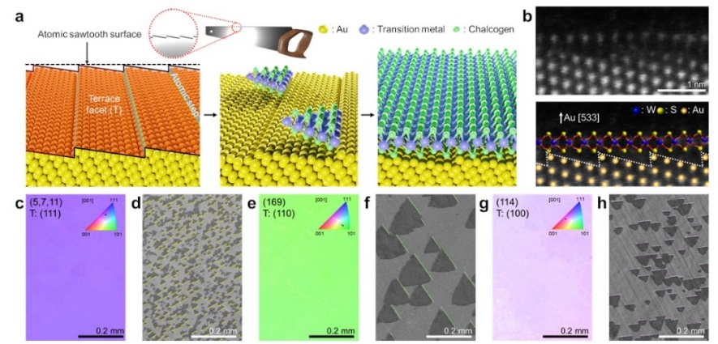
Fig 1. Growth of single-crystal WS₂ on atomic sawtooth Au surface. a) Schematic illustration of WS₂ film grown via an atomic sawtooth Au surface. b) Cross-sectional ADF-STEM image and the corresponding ball-and-stick model of as-grown WS₂ on an atomic sawtooth Au (533) surface. c,e,g) EBSD IPF maps and d,f,h) SEM images of coherently aligned WS₂ grains on Au (5,7,11), (169), and (114) with respective (111), (110), and (100) terrace facets.

